Table of Contents

- Some Things to Note 2
- Getting Started 2
- Managing your Account 3
Test Email Addresses
Changing your Password
- Creating a new issue 5
- Editing 6
The Edit - overview page
Editing the Content, adding images, links and tables
Editing an existing newsletter
Quick preview
Edit newsletter subject and filename
- Preview 9
- Test 9
- Creating a Welcome Email 10
- Managing your Mailing List 11
Adding Subscribers to you List and What Happens Next
Viewing your Mailing List
Downloading your Mailing List
Changing the Fields in your Mailing List
Personalise your Mailing List
- Send 12
Send Criteria
Sending a Single Copy
View your History and Scheduled Newsletters
- Newsletter History and other Statistics 15
Mailing List History
Deleting Unsent Newsletters
- Trouble Shooting 17
Subscriber is unable to access your newsletter
Notification of new subscriber, but no name given in email
- Monthly Support 17
Feedback
Bounced Email Reports

1. Some Things to Note

Your account can only be used by one person at a time. As a result you must remember to log out when you are finished. If you forget to log out you will see a message telling you that someone else is using the system. Click Override and you will be able to log in.

JAC is best viewed with Internet Explorer as it allows you to see all the formatting options that you won’t see with alternative browsers such as Firefox.

2. Getting Started

Log in to the JAC system at www.justaddcontent.co.uk/login.php. The log in form is on the right hand side of the screen (titled Client Login).

Enter your user name and password in the respective fields and click Submit. (You will find your user name and password in the JAC set-up email.)

This takes you to your JAC account.

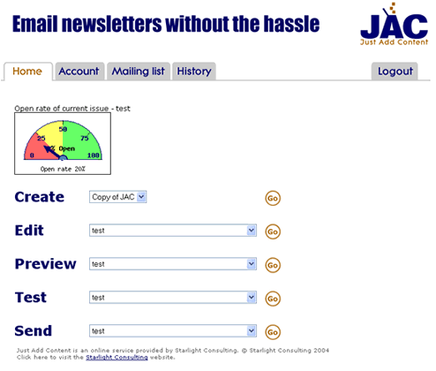

This page is the starting point for all of the features of JAC. When you access the home page for the first time, you may not have any entries next to Edit, Preview, Test or Send – this is because you need to create an issue of your newsletter first.

You may also have a blank odometer. This will change once you’ve sent your first newsletter, to show the open rate.

3. Managing Your Account

From the Home page, click on the Account tab.

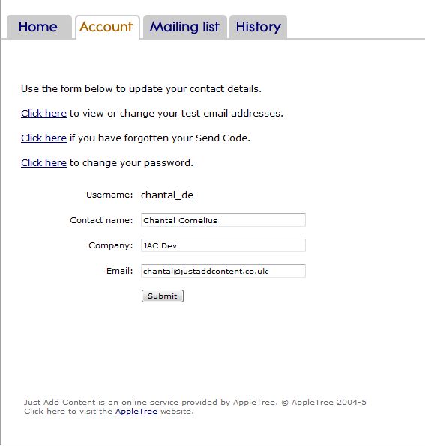

On this page, you can update your contact name and email address. These are the details that appear when you send your newsletter to your mailing list.

The company name is only used for JAC’s internal processes.

If you have forgotten your send code click the link and it will be sent to the email shown on this screen.

Test Email Addresses

From the Account page, click on the first link to view or change your test email addresses.

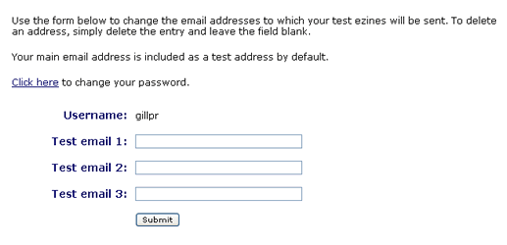

Your own email address is included in the test automatically. You can specify up to three additional email addresses.
Before you publish your newsletter, you can send a test version to yourself and other people, to check it. Test versions are not personalised.

If you have forgotten your Send Code
If you have forgotten your Send Code, click the link and it will be emailed to you.

Changing your Password

From the Account page, click on the link to view or change your account password.

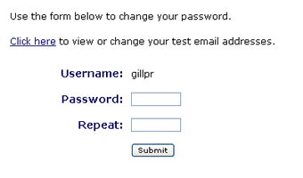

Type your new password into both boxes and click Submit. JAC will check that you’ve entered the password identically and then update your account.

If you forget your password, email admin@justaddcontent.co.uk to tell us and we can reset it for you.

4. Creating a New Issue

To create a new issue of your newsletter, click the Go button next to Create. If you have more than one template to choose from, use the drop down box to select the one you want to Use.

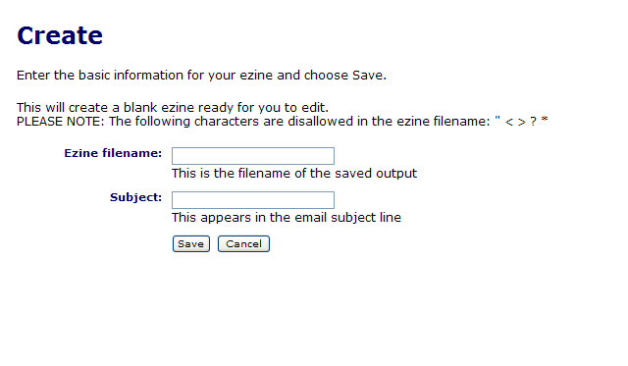

Enter the filename of this issue of your newsletter. This is the name that JAC will use to save your newsletter – it will not be seeen by the recipient of the newsletter. This should be unique, allowing you to tell the different issues of your newsletter apart, e.g. October 2008 Presentations. You can use limited punctuation in this field. If you use something that JAC does not allow, you will see a message telling you. In general, avoid using punctuation in the filename.

Enter the subject of this issue. This will appear in the newsletter when it is sent to your mailing list. You should always use the same format for this and ideally start with the newsletter name followed by a short indication of the content of the newsletter (e.g. Scribbles – How Do You Use Presentations?)

Tip – open ended questions are good for encouraging your readers to open your newsletter.

Choose Save when you have completed the two fields and JAC will take you to the Editing page.

5. Editing

The Edit – overview page

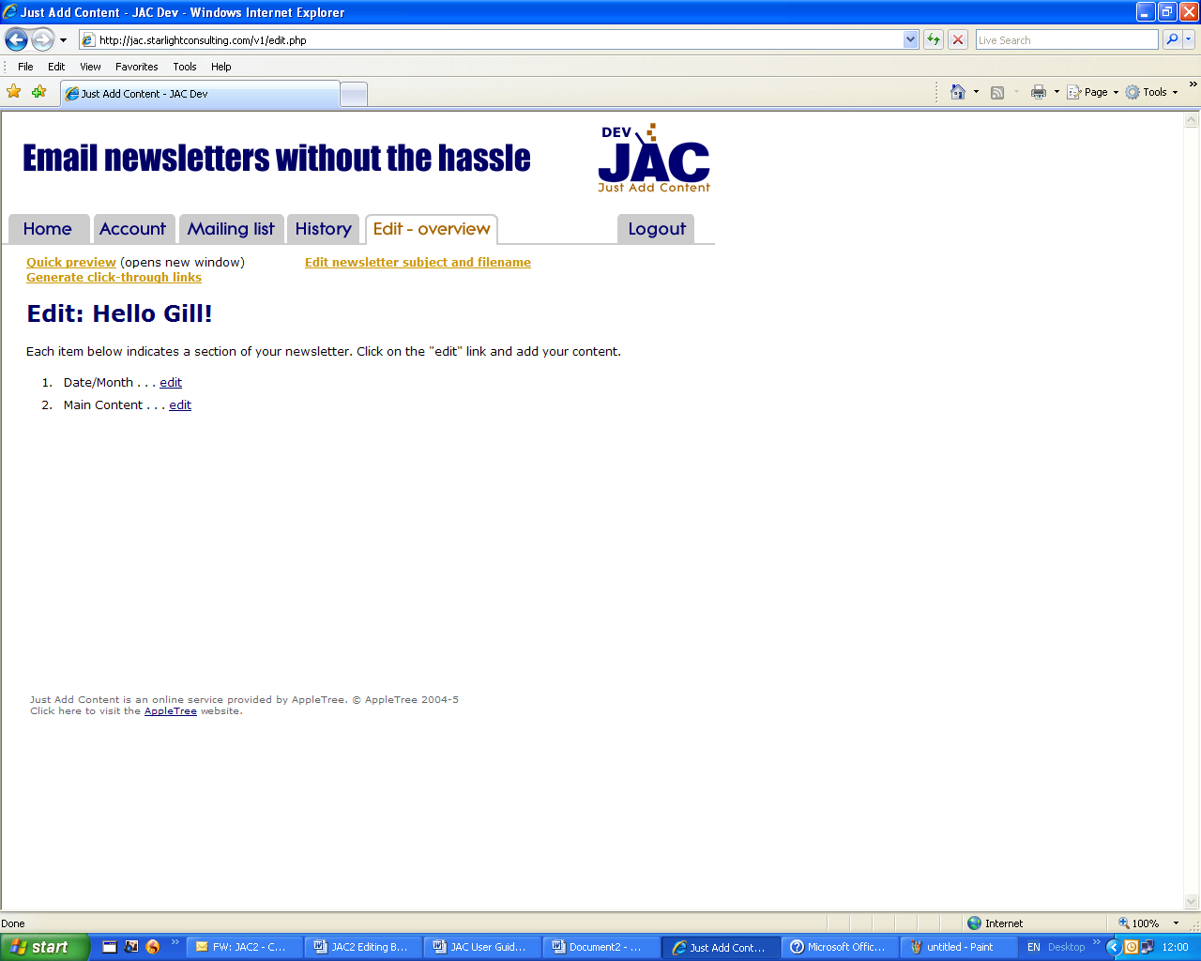

The editing page shows the list of sections you have in your newsletter.

To add content to, or edit one of the areas, click on the edit link.

Editing the Content

The screen for each section of your newsletter will look like this, with the name of the section at the top.

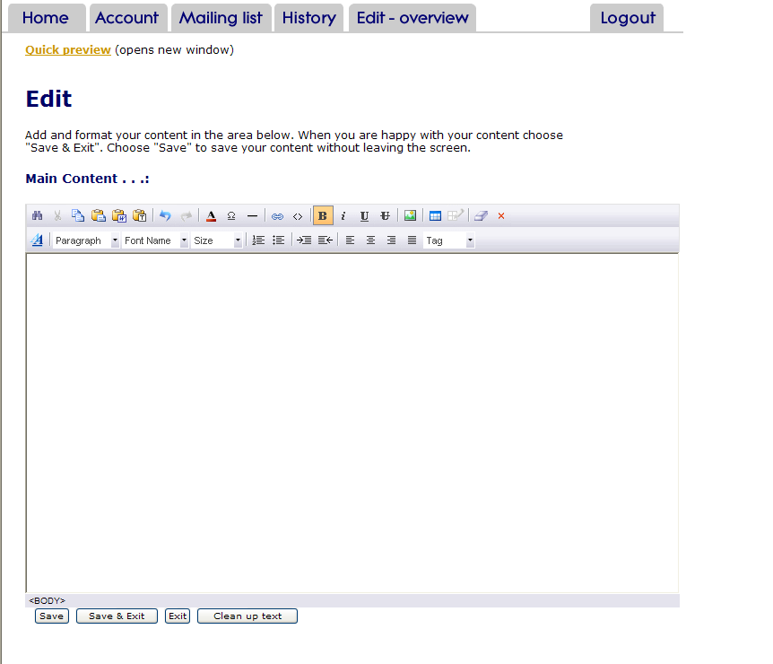

Many sections have titles – fill in the empty box next to the word ‘Title’.

Add your content using the different paste buttons explained below, clicking the Save button regularly.

Here is an explanation of all the buttons on the JAC editing toolbar.

Starting at the left hand side of the top row:

Search. Find and select specific words within your text. You can use this button to replace words with alternatives
Cut. Highlight a section of text and remove it
Copy. Copy a selected area and put it on the clipboard so you can paste it later
Paste. Use this button to paste text that you have copied from within the text that you have already loaded into JAC. Do not use it for copying text from outside JAC

Paste from Word. Use this button to paste text from Word, Notepad etc into JAC. Most formatting – bold, bullets etc – will be copied into JAC with the text

Paste Text. Use this button to paste text into JAC without any formatting. When you click this button, you will be asked to paste your text into the box. Click insert and it will be pasted into your newsletter

Undo. Undo the last thing you did
Redo. Redo the last thing you did
Foreground colour. Change the colour of your text .Use this button carefully and avoid filling your newsletter with colours that don’t work with the set styles provided for you

Special Characters. Insert characters such as © and ® into your text

Line. Draw a line across your document

Bookmark. Use to jump from table of contents to somewhere else in the newsletter. Highlight the text to be jumped to (NB this can only be copy within the main edit box, not a title above it), click the button and type a bookmark name into the dialogue box. Click insert and then OK.

Add Goto Bookmarks. Use to jump from table of contents to somewhere else in the newsletter. Highlight the text in the table of contents. Select the relevant bookmark to be jumped to from the drop down list and click OK.

Hyperlink. Create a hyperlink to a web page or an email address. Select the source from the first drop down box and then type of paste in the URL. Click insert

You can type a website address directly in the content box and JAC will identify it as a hyperlink for you. If the address is very long, it may affect the width of any columns you use in your newsletter. In these cases, use the above procedure, highlighting text such as ‘Click here’.

Tip – to set the text for the subject of an email generated through a link, type name@address.co.uk?subject=whatever you want to write and click insert.

View/edit source. Shows the HTML formatting of your newsletter. This can be useful if you need to remove formatting from a section of your newsletter

Bold, Italic, Underline and Strikethrough. Apply formatting to your copy

Image. Insert an image into your newsletter

Click your cursor where you want your image to appear and click the Image button.

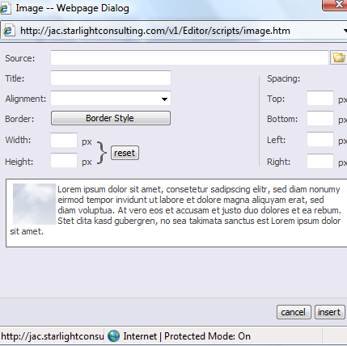

Click on the folder icon to the right of the Source field to select the image to insert.

- If the image has not yet been uploaded to JAC, click Browse and select the image from wherever it is saved on your computer. Once you have located the image click upload and then OK. Use the drop down menu next to Alignment if you want to wrap text to the left or right of your image. Add a border if you want to. Add spacing – 10px to the right or left is a good guide – if you want to. The mini preview screen will show how your image and text will sit together. Resize the width and height if you think your image isn’t quite the right size for your newsletter. When you’re happy with it, click insert.

If you have already loaded images into your account, just select the one you want to use and click OK. Follow the instructions above for alignment etc.

Insert table. Insert a table into your newsletter. Use the grid to select the size of table you want – highlight the rows and columns and then click on them; or use the Advanced Table link at the bottom of the grid.

Edit table/cell. To make changes to the size or look of the table place your cursor anywhere inside the table (don’t select the whole table) and click this button to see three options:
- Table Size – add or delete columns and rows
- Edit Table – change the width of the table and format it by changing the background colour, border and alignment within your newsletter
- Edit Cell – change the size and formatting of individual cells.

Remove formatting. Use this button to remove formatting .This will remove ALL the formatting AND links within the section in which you’re working.

Clear all. Delete text in a specific section by clicking this button.

Editing an Existing Newsletter

You can edit a newsletter after you have created it. Select the name of the issue you want to edit from the Edit menu on the Home page and click Go. This will take you to the Editing – overview page.

Quick Preview

While you are editing your newsletter, you can see how it looks by clicking on the Quick preview link. This opens a new window with a preview of what your newsletter looks like. Make sure you click Save before you do this, so that you see your most recent changes.

Edit Newsletter Subject and Filename

Once you’ve created a newsletter issue, you can go back and change the filename or the newsletter subject. From the Editing – overview page, click on the Edit newsletter subject and filename link. This will show you the newsletter name and subject, where you can make changes.

6. Preview

This generates the newsletter and lets you display it in a separate window. You can also use the Quick preview link in the Editing window.

7. Test

This sends the newsletter out to your test addresses. To start the send, just click on the link. You can specify your test addresses on the Account page.

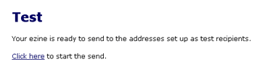

Your own email address is automatically included, so if you don't want to test the newsletter with any other addresses then you don't need to change anything.

When you send a test version, if you’ve included personalised fields such as ‘Dear [[Name]]’ JAC will use the first record of your mailing list and insert that name into the newsletter (or the Personalised name that you’ve chosen – see below for how to Personalise your Mailing List – rather than your own name.

For your first two issues, please add Chantal@JustAddContent.co.uk and we’ll look over the newsletter for you and give you some feedback, before you send it out.

8. Creating a Welcome Email
When someone subscribes to your newsletter, or you add them to your mailing list, you can decide whether or not to send them a Welcome email. If you want to send them one, create a new issue of your newsletter, using whatever welcome text you would like to use. An example is shown below.

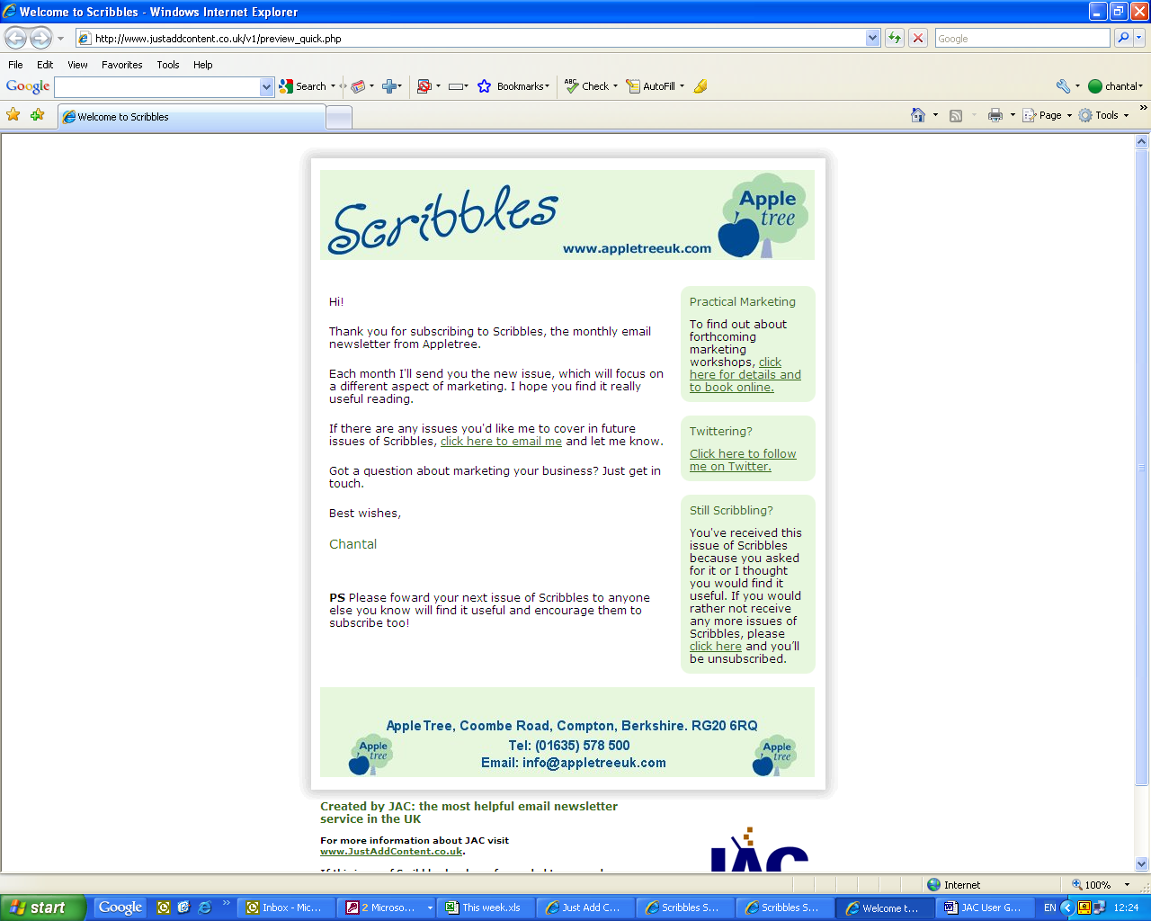

Next go to the Mailing List page and click on Mailing list settings at the top of the page. For the Send a welcome email to each new subscriber: option select Yes from the drop down list. In the To change your welcome email layout please choose from option, select the Welcome email you have created from the drop down list and click Submit. Return to the Mailing List page and the Welcome email you have chosen will show as the Default setting to be sent to new subscribers.

To change the newsletter that is sent out as the Welcome email, select a different issue from the To choose a different welcome email layout please choose from drop down list, when you add new subscribers individually. You can also decide not to send a Welcome email to a specific new subscriber by selecting Do not send a welcome email this time from the same drop down list.

9. Managing your Mailing List

Once your mailing list is set up, you can manually add or remove individual names to the list through the Mailing List page. You can also download your mailing list at any time.

Adding Subscribers to your List and What Happens Next

To add names to your mailing list, simply enter the details into the fields on this page and click on Submit.

Below these fields you will see three bullet points which tells you what happens when someone is added to/subscribes to your mailing list. To change these settings, click on Mailing list settings at the top of the page.

You can change the following options:

Notify me when a new subscriber joins my mailing list: Yes is recommended so that you can ask any other questions, such as how did you hear about the newsletter. Do not reply to the email you receive as it will come from admin@justaddcontent.co.uk.

Enable subscribers to view and edit the information in any additional fields: Optional, depending on how much information you want to collect

Send a copy of my latest newsletter to each new subscriber: Yes is recommended, so that a new subscriber doesn’t have to wait to long to receive a newsletter from you.

Require new subscribers to confirm their subscription by replying to an email: Optional and can help prevent spiders or spammers from trying to subscribe.

Send a welcome email to each new subscriber: Optional. If you decide to do this send a Welcome email, follow the instructions above in the Creating a Welcome email section.

Viewing your Mailing List

Click on View your mailing list at the top of the Mailing List page.

You will see a table containing all the subscribers on your mailing list. You can search for a subscriber by entering details in the Search for: field and selecting the field in which you want to search from the drop down box. Click Submit to start the search.

You can also look through your list by using the Next button or by clicking on A-Z to see email addresses starting with that letter.

To delete subscribers from your list, check the box next to a name and click on Del at the top of the column, before moving to a different page of your mailing list. Click OK to confirm the deletion or Cancel to return to the mailing list.

To edit a subscriber’s details click the pencil next the name. Make the changes you need and click Update.

Downloading your Mailing List

To download your mailing list, click on Download your mailing list at the top of the page and follow the instructions on the pop up box.

Changing the Fields in your Mailing List

Click on Change the fields in your Mailing List and you will see a list of all the fields you use in your mailing list. You cannot remove the name or email fields, but you can add others, by filling in the Add a new field box and clicking Submit.

You can also remove a field by clicking Remove next to the field name. When you remove a field, you will also delete all the information stored in that field.

Personalise your Mailing List

When you publish your newsletter, JAC takes a name from your mailing list and inserts it into your newsletter. This means that when you put a link to your newsletter onto your website, you get a random name on your newsletter. Now you can decide what you name you would like to include, after the 'Dear' or 'Hi' that you type in.

On the Mailing list page click on the Personalise link. Type the name you want to use into the 'name' field. Recommended names are 'Reader' or ‘Subscriber’ and can be combined with the name of your newsletter. Click update to complete the set up.

10. Send

To send your newsletter, select the current issue from the drop-down menu (it will be selected by default) and click Go. This takes you to the Send – overview page.

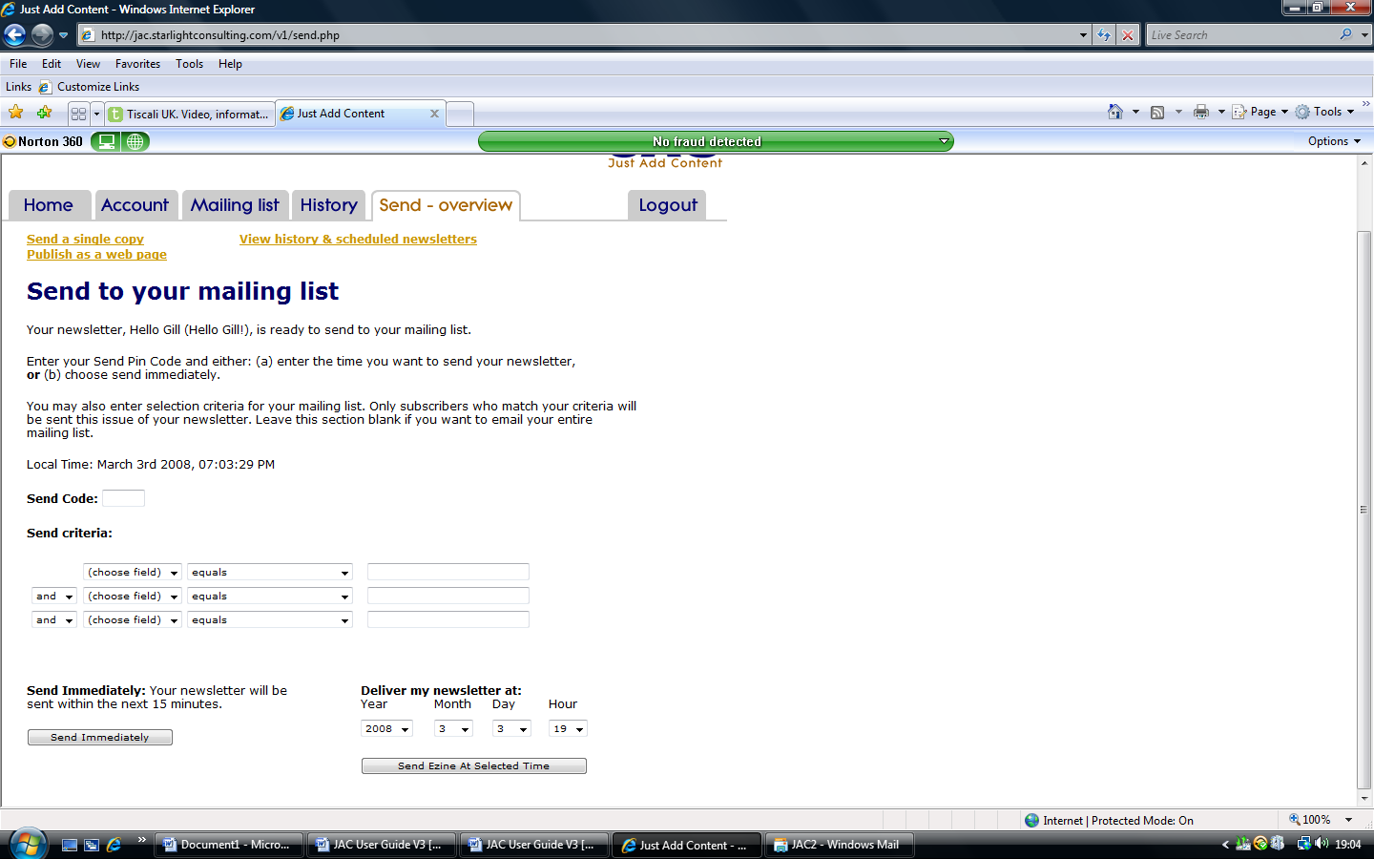

To send your newsletter, enter your 3 or 4 digit Send Code and either click on Send immediately, or specify the date and time you want and click on Send ezine at selected time.

If you choose Send immediately your newsletter will be stored and sent in the next 10-15 minutes. You'll receive an email to confirm that your newsletter is scheduled to be sent. Once your newsletter has been sent to your mailing list, you'll receive an additional email telling you how many emails were sent.

If you choose Send ezine at selected time your newsletter will be sent at the date and time you specify. You will receive an email to confirm that your newsletter has been scheduled and an additional email once your newsletter has been sent.

You can’t send the same newsletter to your entire mailing list more than once, so be sure always to create a new issue of your newsletter from scratch, rather than trying to just change the content of an existing newsletter.

You can’t send a single copy of a newsletter until it has been published to your mailing list. Use the Test function to send test versions, changing the test addresses as necessary (see section 7).

If you forget your Send Code, click on the Account tab and click on the link. You will receive an email from JAC containing your Send Code.

Send Criteria

To send your newsletter to your entire mailing list, don’t worry about using the Send Criteria, but …

If you have added fields to your mailing to segment your list into different groups (e.g. clients and prospects) you can use the Send criteria to select specific groups. Click the arrow next to (choose field) to select the field in which the information is stored. Make your selection from the next field and if you have chosen equals, contains etc, type the relevant word(s) into the third field.

For example, if you have a field called Client? in your mailing list, with the word Yes to denote which contacts are clients, select Client? from the (choose field) box, equals from the next one and type Yes into the third box.

Sending a Special Issue

If you’d like to send a special issue of your newsletter – for instance promoting an event – you can send it normally, but if your mailing list is set so that new subscribers receive the latest issue when they sign up, they’ll receive this, rather than an actual issue of your newsletter. To avoid this problem, use the Send Criteria to select all email addresses that contain @. This will send your special issue to everyone on your list, but the special issue won’t be recognised by JAC as the latest issue.

Sending a Single Copy

You can send a single copy of your newsletter to an email address. This is useful if you want to send your newsletter to a new contact before they decide to join your mailing list.

Click on the Send a single copy link at the top of the page.

Enter the name and email address of the person you want to send your newsletter to and click Send.

If you want to permanently add this email address to your mailing list, tick the checkbox by Add this email address to my mailing list and then choose Send.

Viewing your History and Scheduled Newsletters

You can check the status of all of your newsletters by clicking on the View history & scheduled newsletters link on the Send page.

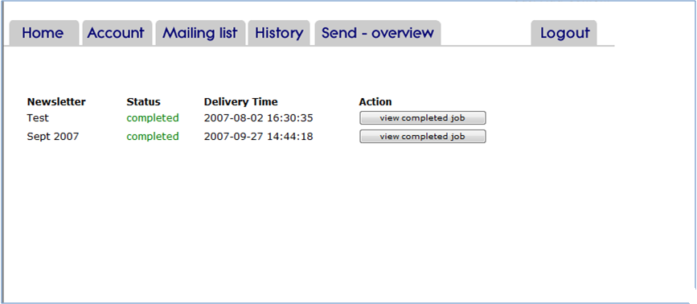

This page confirms when your newsletters have been sent. You can also view and delete issues that have not yet been published. If you need to make a change to a newsletter once you’ve scheduled it for delivery and the status says “pending”, you can still make changes to the newsletter without having to change the publication time –as long as you have enough time. The newsletter that will be sent will be your latest version, including any changes you have made. If the newsletter is due to be sent in the next few minutes, click on Delete. This will stop the newsletter from being sent – it won’t delete the actual newsletter. You can then make the changes you need to make and reschedule the publication of the newsletter.

If there is a problem with the delivery of your newsletter it will be listed here.

11. Newsletter History and Statistics

The History page lets you look at the newsletters you have already published and get more detailed statistics.

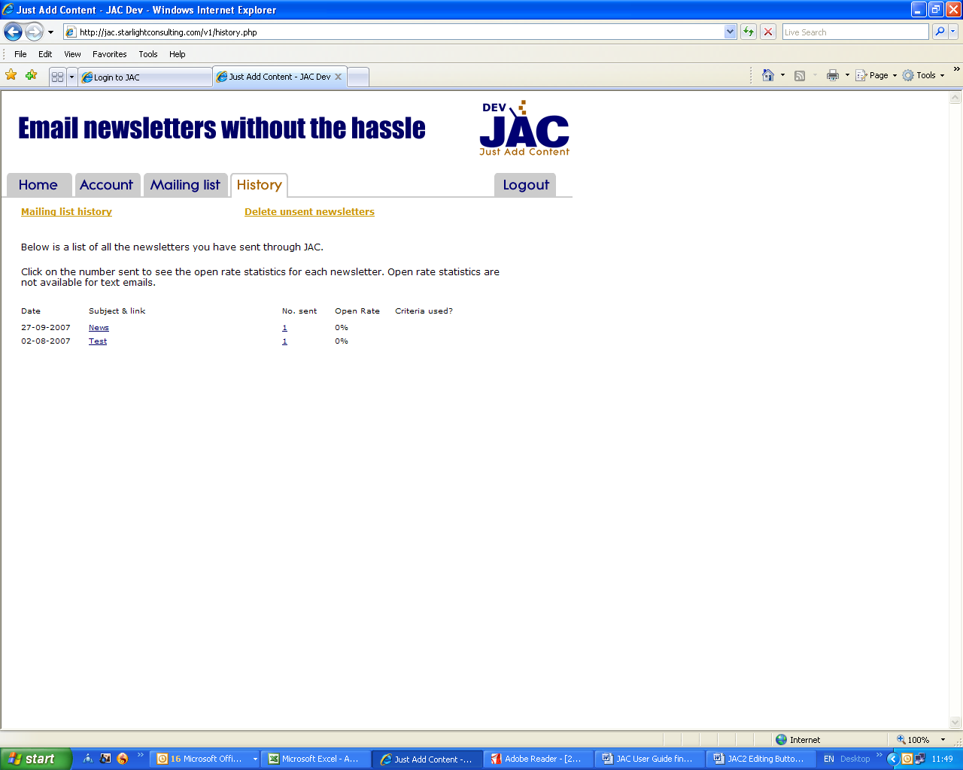

Each published issue of your newsletter is listed, showing the date it was sent, the subject, the number sent, any criteria you used and the open rate as a percentage. Click the subject of a newsletter to see the web copy of that issue. Click on the number sent to see a graph of how many times your newsletter was opened and when. Up to 45 days of history are stored for each issue.

Adding newsletters to your website

If you want to paste a link to this newsletter onto your website or into an email, click the link to an issue of your newsletter, copy the URL at the top of the page and paste it into your website.

Alternatively, you can add your newsletter with your own URL. To do this, go to the History page of your JAC account and right click on the newsletter you want to put onto your website. Choose ‘Save Target As’ from the list, choose where to save it on your computer, give it a relevant name and click ‘Save’ or ‘OK’.
Then you need to go to your website and log into your CMS, so that you can add this document. If you don’t have access to your website, you can send the file you’ve just saved to your web developers and ask them to do it. If we at Appletree look after your website for you, just let us know and we’ll do it for you.

Mailing List History

When you send your newsletter, some of the emails you send it to will bounce - because the email address has changed or that person has left that business.

At the end of each month JAC sends you an email to tell you which email addresses have bounced. It's worth you going through this list and checking, updating and changing any addresses which you know have changed. You can also delete ones that aren't getting through, which will increase your open rate percentage.

You can also look at the emails that have bounced whenever you want to. Just log into your JAC account and go to the History section. Click the Mailing List History link and you'll see four graphs - new subscribers, unsubscribes, Bouncing email addresses and Unsubscribed bounced email addresses.

Bouncing email addresses - shows the number of addresses that have bounced. Unsubscribed bounced email addresses - shows the number of email addresses that have bounced three times and have been deleted from your mailing list. While JAC does this automatically for you, it's worth looking at the addresses that have been deleted. There may be some on the list that you want to correct and put back onto your mailing. Use the drop down lists at the top of the page to see the names and email addresses
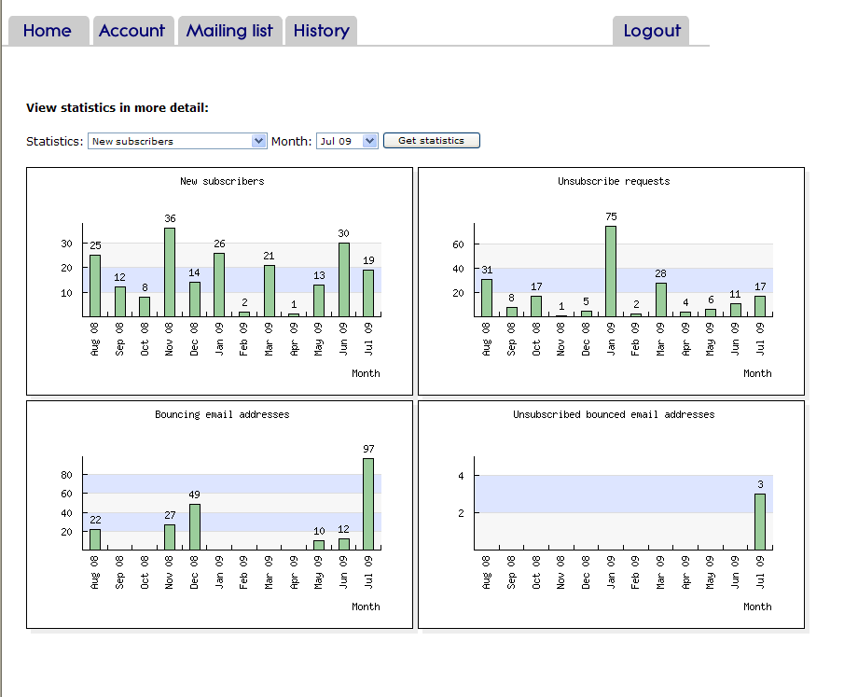

To see exactly who has subscribed, unsubscribed, click on the drop down arrow by New subscribers to select the statistics you want. Select the month from the next box and click Get statistics. This will show a list of who and when.

Unsubscribe feedback

If any unsubscribers leave any feedback when they leave your mailing list, this is sent to us at JAC and we’ll pass it on to you at the of each month.

Deleting Unsent Newsletters

Once you’ve created a new issue of your newsletter, if you decide not to publish it, you can click on Delete unsent newsletters at the top of the History page. Check the box next to the issue you want to delete and click on Del.

12. Trouble Shooting

Subscriber is unable to access your newsletter

If you are notified by a subscriber that they are having trouble reading your newsletter – it may be because you have an odd character in the title, such as a question mark in the file name of the issue. It is general better to use file names like July 2005 to avoid this problem – the name isn’t seen by the recipient and you can still use your ‘title’ in the subject line.

Notification of new subscriber, but no name given in email

If you receive an email from JAC as the following:

A new subscriber has subscribed to [your company name] monthly newsletter. Email address =

This is likely to have come from an Internet spider. Search engines send out spiders to check websites and follow every link they find. This means we sometimes get blank subscriptions. If you look at your mailing list history, you’ll see that it has not been included, because this spider didn’t leave its email address! Sometimes you’ll get blank unsubscribes – these are triggered by the same thing.

13. Monthly Support

Feedback

We keep a close eye on newsletter statistics – the open rate and growth rate of your mailing list. If there is a problem, such as decreasing open rate, we will give you suggestions as to why this has happened and give you some ideas on how you can increase the rate again. We will also look at the content of the newsletters you have published during the month and send you some constructive comments, to help you keep writing effective newsletters.

We compare the statistics of every JAC newsletter so that we can identify trends, such as declining open rates at certain times of the year.

You can call us at any time during office hours for feedback and advice. If you have lots of questions to ask, or you would like us to fully review the last issue that you published, it is best to contact us in advance and book a telephone call.

Bounced Email Reports

At the end of each month, JAC will send you an email with a list of all the email addresses on your mailing list from which your newsletter has bounced.

After the third bounce in a row, an email address will be removed from the list. To prevent this happening, you should check all the bounced email addresses, to make sure they are correct.

Bounces occur even when email addresses are correct. Some companies won’t let certain emails in, so if this happens, you should let your contacts know that you are trying to send them emails and ask them to let their IT departments know.

